SKIN

composer

At First
- Scene2d is a 2D scene graph for building applications and Uis, using a hierarchy of actors.
- What is a scene graph?
-Is a data structure for storing the stuff in your world, you have a world with sprites, so this are stored in the scene graph.
- His main functionality is to work with actors, groups, events and actions
- You can think of Scene2D as a higher level framework for creating a game built over top of the LibGDX library.
Table table = new Table();
table.setFillParent(true);
table.setDebug(true);
stage.addActor(table);

//skin provides the style to the controls
Skin skin = new Skin(Gdx.files.internal("skin/glassy-ui.json"));

//create buttons
TextButton newGame = new TextButton("New Game", skin);
TextButton preferences = new TextButton("Preferences", skin);
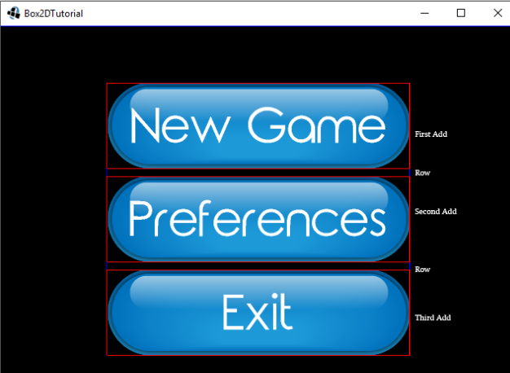
TextButton exit = new TextButton("Exit", skin);

Stage At The Top Of The Hierachy
- This is where the game will take place.
- The Stage in turn contains a Viewport.
- The next major abstraction is the Actor, this are the stuff that make up your game.
@Override
public void create() {
stage = new Stage();
skin = new Skin(Gdx.files.internal("nuevocha/neutralizer-ui.json"));
CrearEscena()
Gdx.input.setInputProcessor(stage);

code snipet ...

table = new Table();
table.setFillParent(true);
stage.addActor(table);

Skin
- Made it with Skin Composer (chaSkin), which provide us a png, json, atlas and fonts. To give style to the actors.
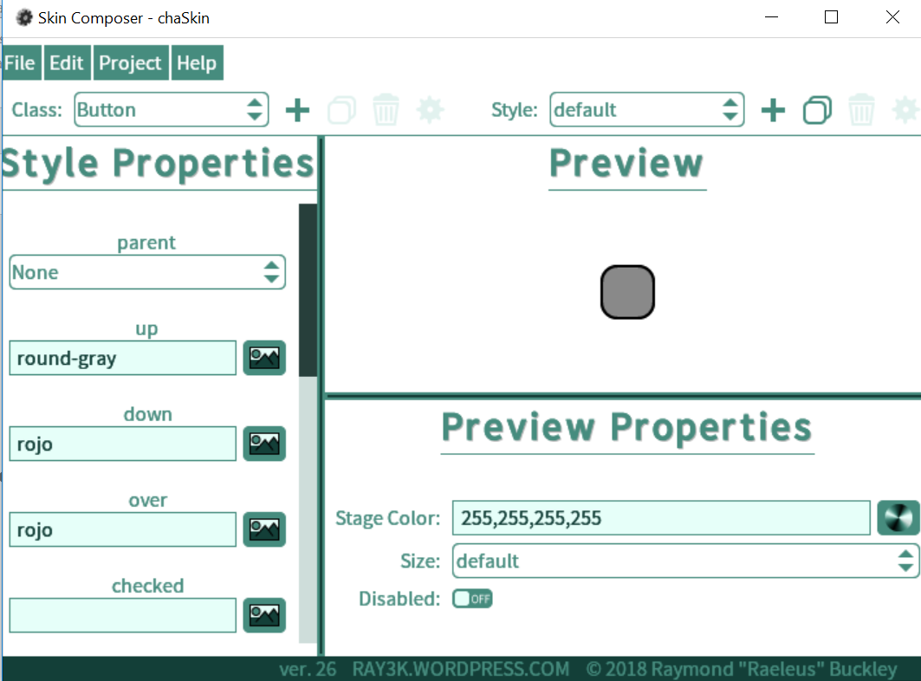

Classes
- Skin Composer can create Buttons, SelectBoxs, Touchpads, Sliders...With different colors, fonts, properties and events (keyup, mouseOver)

Events
- Each control have diferent events and they execute on different ways. For the button, when you click, the selectBox, when you change the selected item.
botonEnviar.addListener(new ChangeListener() { //CAMBIA LA IMAGEN
@Override
public void changed(ChangeListener.ChangeEvent ce, Actor actor) {
table = new Table();
table.setFillParent(true);
stage.clear();
table.add(pokemon); //Label
table.row().padTop(10);
if (seleccionPokemon.getSelected().equals("Charizard")) {
table.add(chaNormal); //Imagen Pokemon
} else {
table.add(starmieNormal); //Imagen Pokemon
}
code snipet...

Example Of Stage
- This stage implements a table and this one have added one label, two buttons, two ImageTextButton(one hidden) and one selectedBox. At the end the Stage add an actor, the “Table”.
